

# *UniX and Linux Essentials*

**ASSIGNMENT - 8**

**SUBMITTED BY:**

**AYUSH KUMAR JHA**

**SAP ID - 500086400**

**Enrollment no - R200220083**

**B.C.A -I.O.T.**

**Assignment 8: -**

**Echo -**

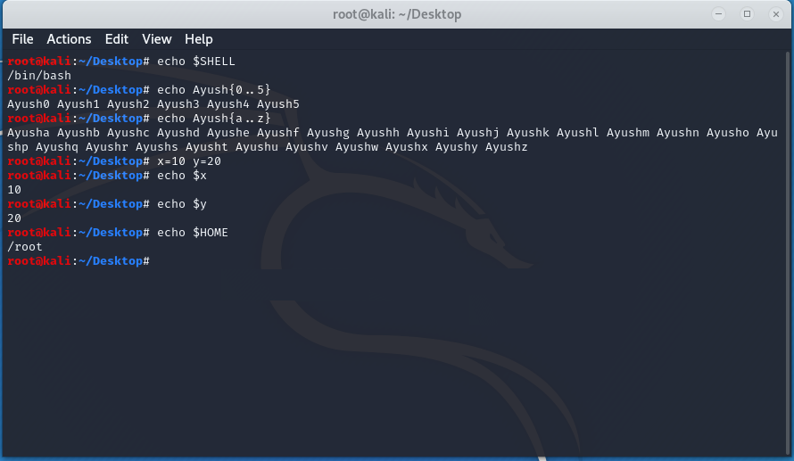

Command-

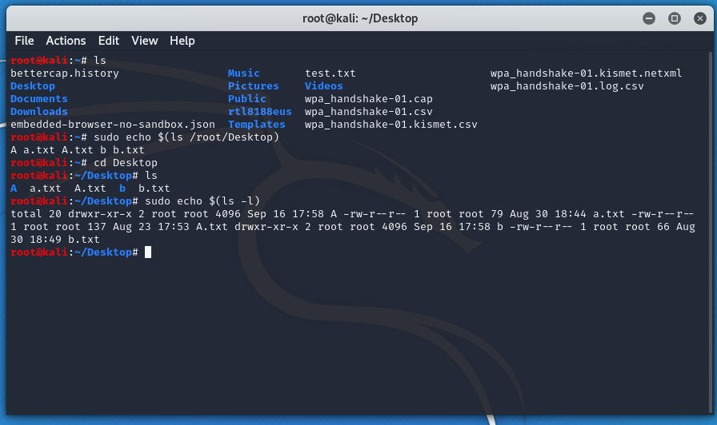

File –

